IIM-Jammu launches summer school programme for classes 10, 11 and 12 students
By: Education Desk | New Delhi | June 24, 2021 1:50:09 pm
The Indian Institute of Management (IIM) Jammu announced the launch of its online summer school programme for the students of classes 10, 11, and 12. The duration of the programme will be of one week, starting from July 3 till July 10.
The aim of the project is to engage young students positively during this pandemic situation. Director of IIM Jammu, Prof B S Sahay envisions the programme as a way to enhance student’s knowledge about various fields and will allow them to explore various career options available to them.
IIM Jammu is not charging any fees for the registration and the initiative has received about 500 applications on the first day. The programme has a fun-based approach with the objective to make learning fun, exciting, and enriching for the students amid the COVID-19 pandemic.
The programme focuses on three main modules. The first module aims for students to discover new opportunities where students will learn about the global business environment and entrepreneurship. The second module aims at learning and acquiring new skills like public speaking, problem-solving, critical thinking, and others.
Finally, the third module will focus upon the self-development of the students through a session that will emphasize the importance of being happy, time management, and the value of adopting a hobby. Overall, the programme is constructed in such a way that it will help students in their holistic development.


Friday, 25 June 2021
IIM Jammu Offers Free Entrepreneurship Course for School Students
IIM Jammu to conduct online summer school for students of classes 10, 11 and 12 for free. The IIM claims to have received 500 applications on the first day of registrations
The Indian Institute of Management (IIM) Jammu has launched an online summer school for students of classes 10, 11, and 12. The programme structure has focused on three main modules including entrepreneurship, financial literacy, critical thinking, and self-development.
The one-week program will start from July 3 till July 10. The summer school is an IIM Jammu-sponsored programme, and will not charge any fee from the students.
The first module aims to teach students about the global business environment and entrepreneurship. The second module focuses on learning and acquiring new skills like financial literacy, public speaking, problem-solving and critical thinking, etc.
The course also features a third module which imparts knowledge on the self-development of the students. In this session, the moderator will highlight the importance of being happy, understand the value of developing a hobby, and the significance of time management.
“The overall programme will help the students in their holistic development and help them realize their true potential," said IIM Jammu in an official statement. Prof BS Sahay, Director, IIM Jammu, said that this programme will expand students’ knowledge across various disciplines and help them explore new career options.
The IIM Jammu Summer School has received about 500 applications on the first day of the registrations, claims the institute. “The core objective of the program is to make learning fun, exciting and enriching. The innovative teaching pedagogies used by the faculty members and subject experts will create a positive learning environment by engaging the students in the best possible way," reads the release.
The program coordinators, Dr Archana Sharma and Dr Kulwinder Kaur, have done extensive research in developing the program modules and are working hard to make this program a great success.


Friday, 25 June 2021
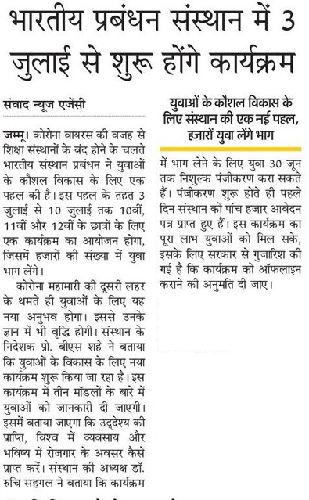


Friday, 25 June 2021
